APP DEV AND EMERGING TECHs

Jericho Bruce Rivero | BSIT

Activity 1

1. Write a C Language system that will display the perimeter of a rectangle using the below data.

Height is 3 and width is 15. Display also the value of Height and Width.

Put your source code and screenshot of the running program below.

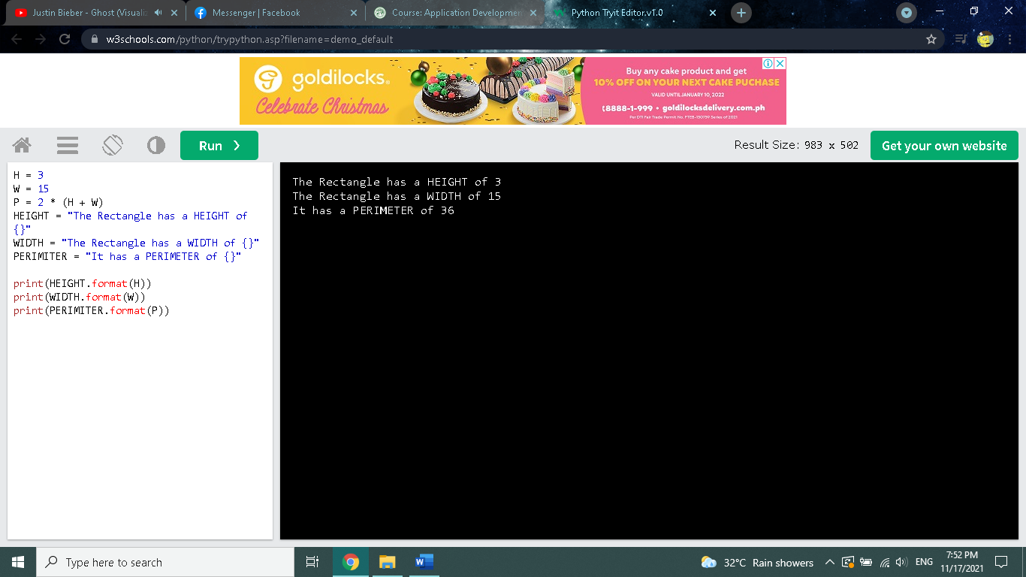

H = 3

W = 15

P = 2 \* (H + W)

HEIGHT = "The Rectangle has a HEIGHT of {}"

WIDTH = "The Rectangle has a WIDTH of {}"

PERIMITER = "It has a PERIMETER of {}"

print(HEIGHT.format(H))

print(WIDTH.format(W))

print(PERIMITER.format(P))